**Using Twitter Application with Azure Active Directory**

Step 1:

Open below link & Login with Azure credentials:

<http://manage.windowsazure.com/>

Step 2:

Select “Active Directory”

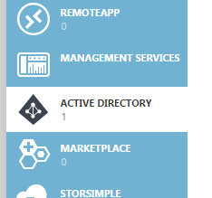

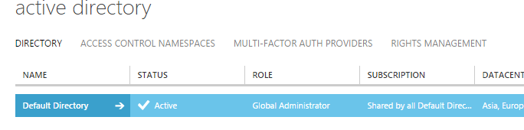

Step 3:

Click on “Default Directory” Name

Get Azure Active Directory Premium to perform operations

Click on “Try it now”

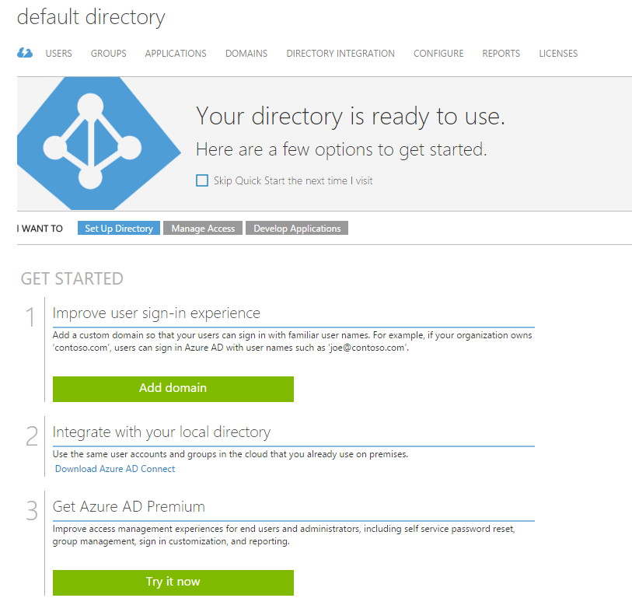

Click on “Try Azure Active Directory Premium Now” option

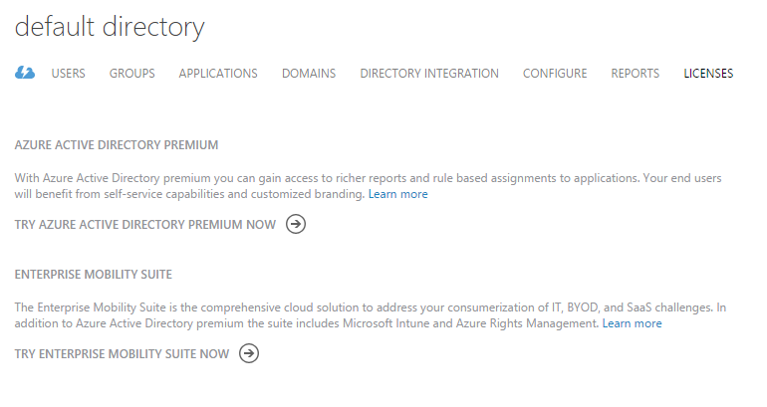

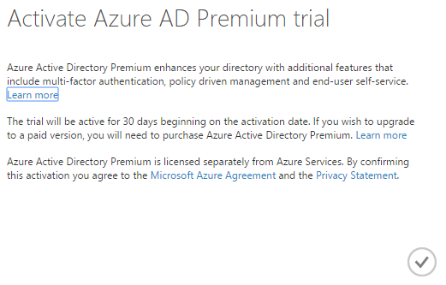

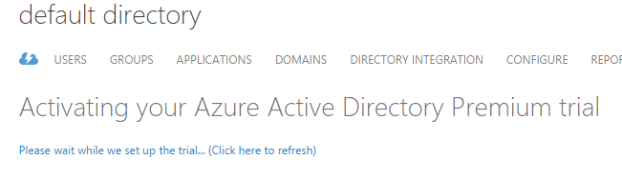

After changing normal active directory to Premium

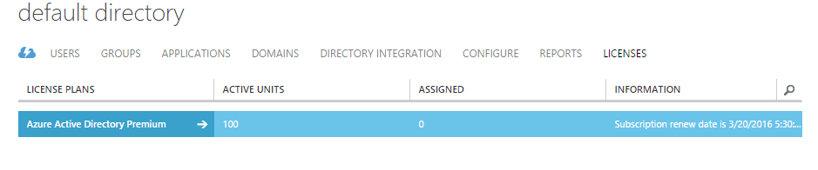

Step 4:

Now add new users in organization select “USERS” tab & click on “ADD USER” option from bottom.

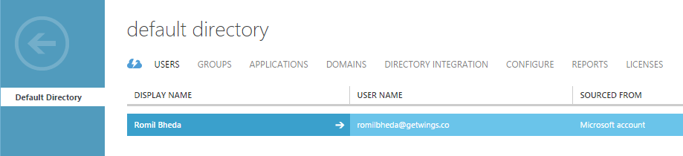

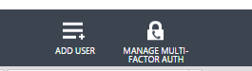

Step 5: Choose user type & enter username

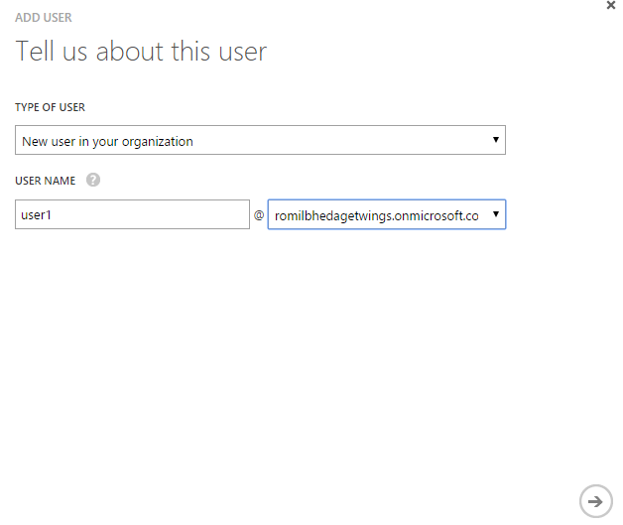

Enter First Name, Last Name, Display Name & Set role: user, admin, global admin

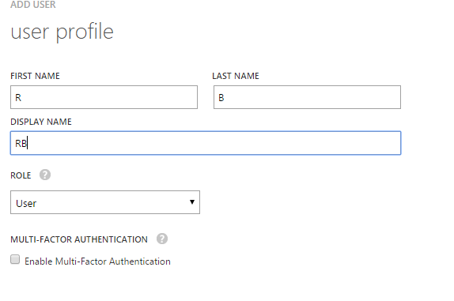

Click on “create” password button

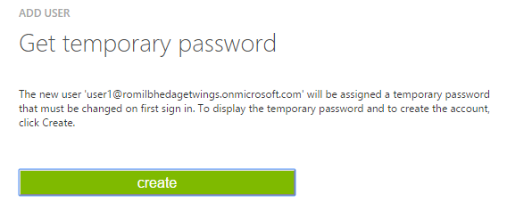

Note: please save temporary this password for first time login

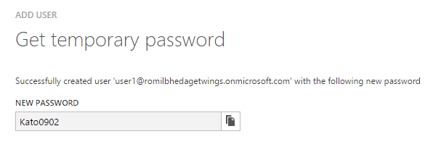

New user

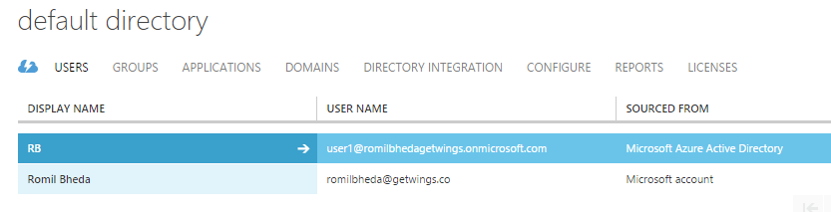

Step 6:

Again click on cloud tab & click on “Manage your licenses”

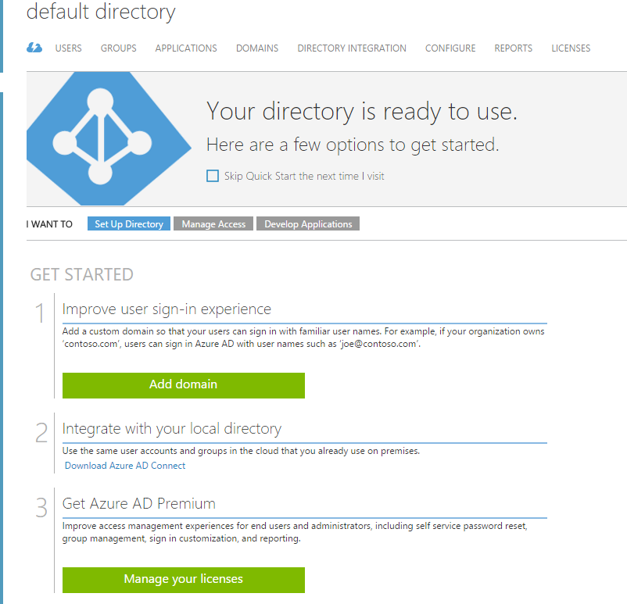

Step 7: click on “Azure Active Directory Premium” option 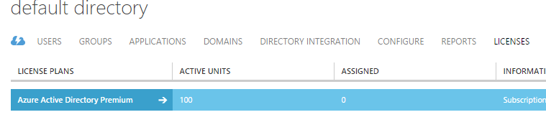

Select “Assign users”

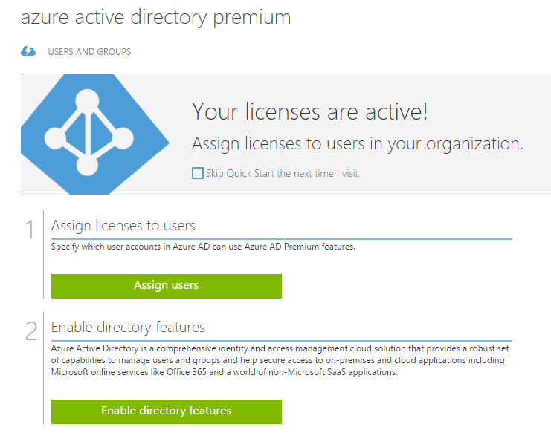

First select “All Users” from drop-down & click on right option. All users set with unassigned status

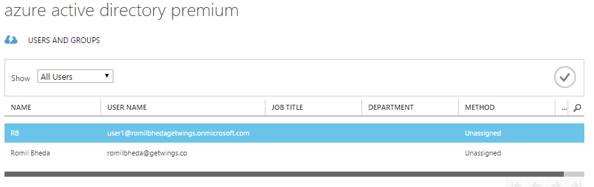

Select both users & click on “Assign” option



After assigning all users

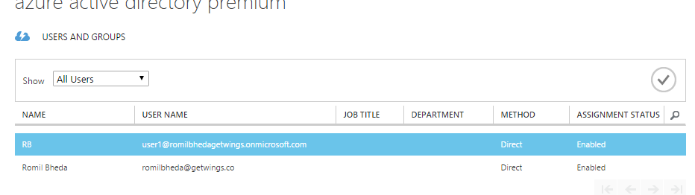

Click on back button

Step 8: Select “APPLICATIONS” TAB

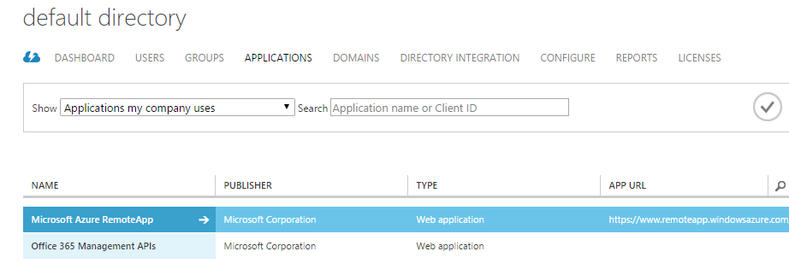

Click on “ADD” button to Add application

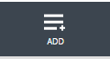

Select “Add an application from the gallery”

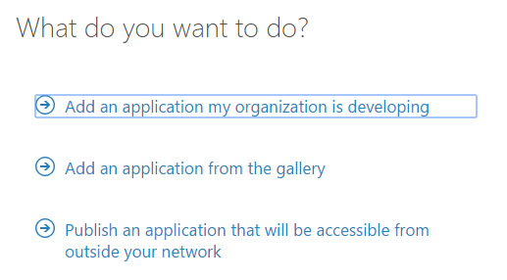

Step 9: all application categories for organization. Search for “twitter”

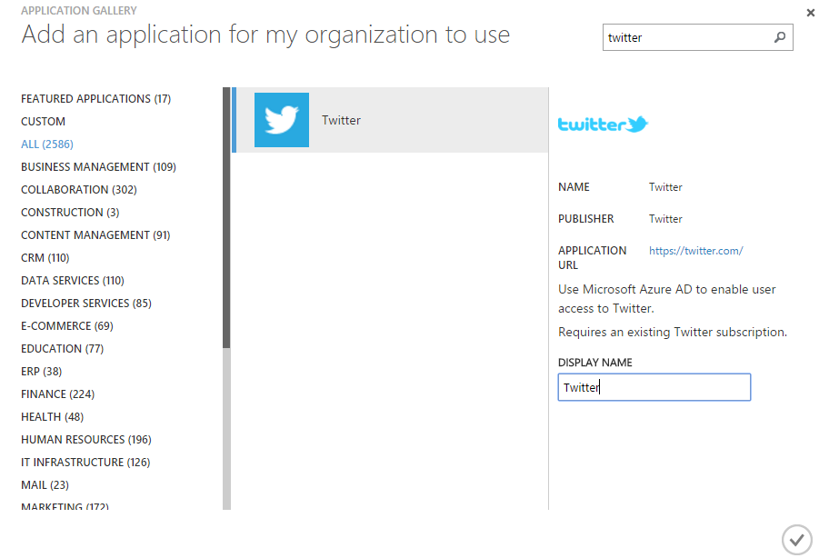

Twitter settings page will open

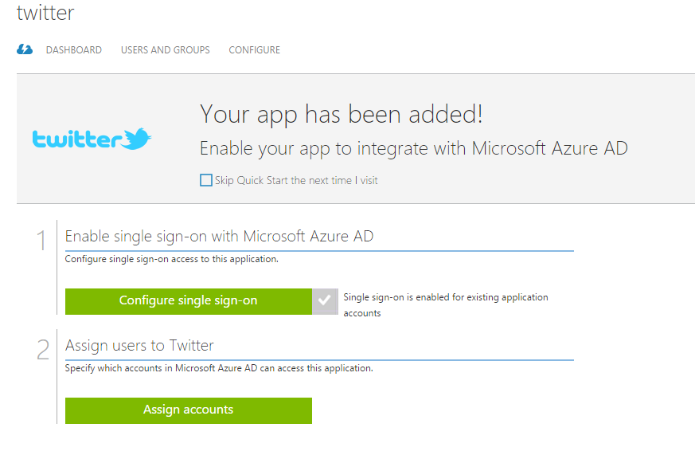

Click on “Assign accounts”

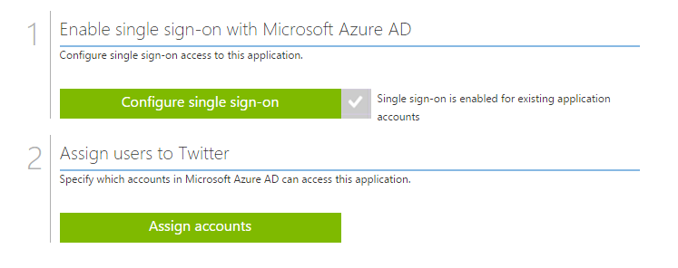

Again select “All Users” & click on right button

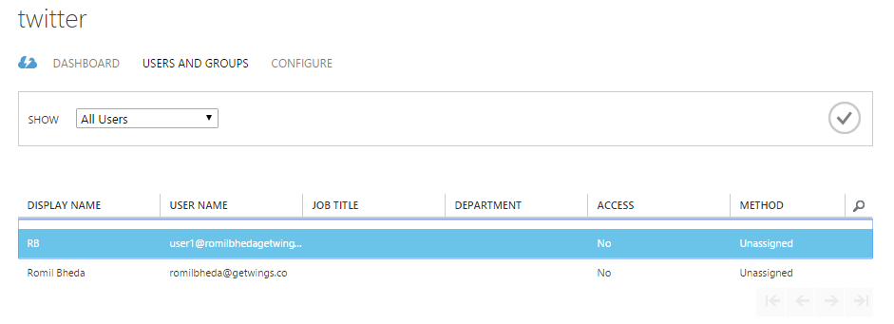

Select user & assign twitter application to user

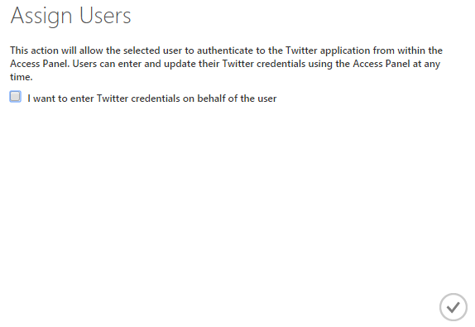

Step 10: Now open below link in another browser or private browser

<http://myapps.microsoft.com/>

Step 11: Enter user id & password

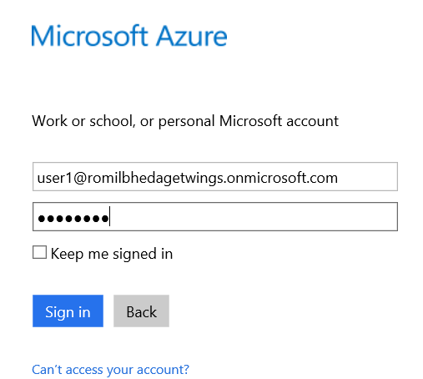

Password update windows will open because temporary password will only first time.

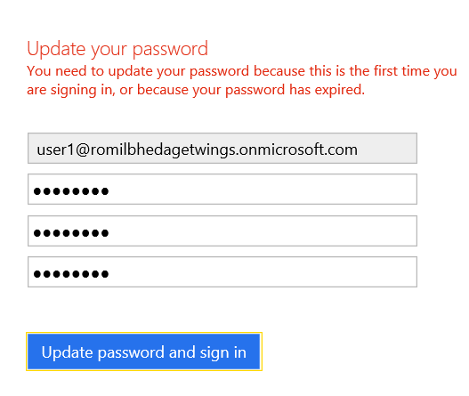

Step 11: To Display application we need to install “Access Panel Extension”.

Click on “Install Now” button & install extension.

All installed applications listed here

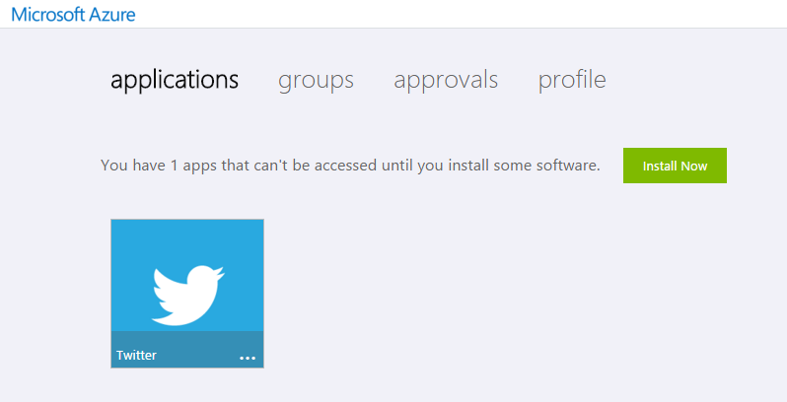

Click on Twitter application icon.

Step 12: Enter twitter account credentials

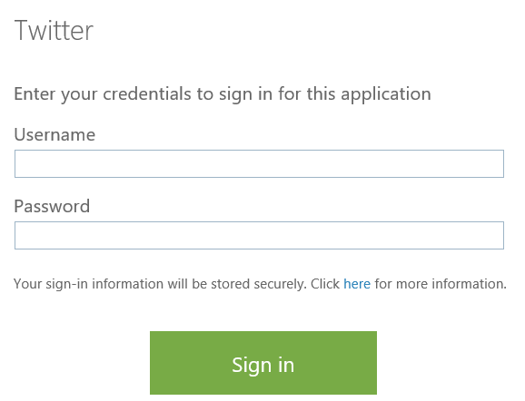

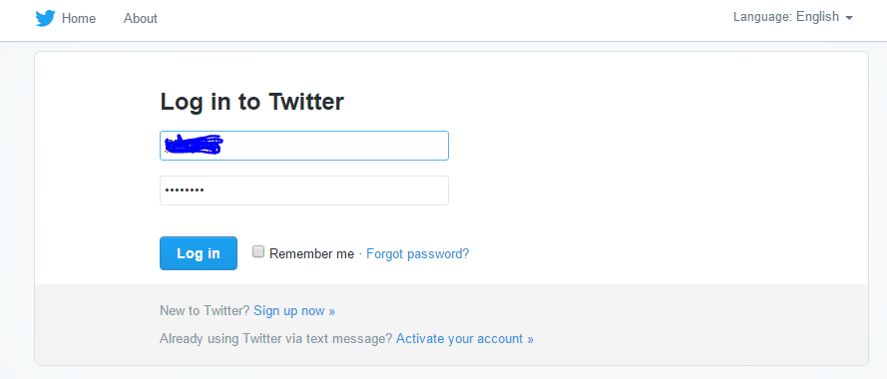

Note:

**In this example, when the user clicks the Twitter icon, they will be logged in to the company Twitter account automatically. If our user leaves the company we can easily disable their corporate access to Twitter, preventing any unwanted content from the company account.**

**In a few short steps, you are now able to provide a quick and easy way for your users to log on to the company applications they need access to (and just as easily restrict access) in a simple easy-to-use web interface. Azure Active Directory is a powerful identity and management tool that can easily be overlooked in the Azure offering. Take a few moments and explore how Azure Active Directory can enable your users.**